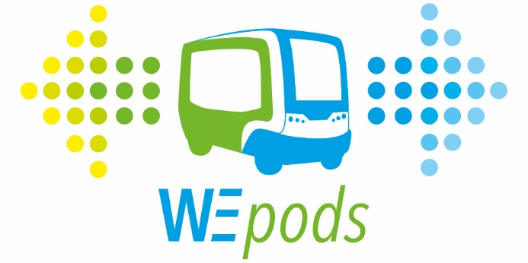 28 January 2016
Promising future for self-driving vehicles
Minister Schultz van Haegen launches test phase of WEpod self-driving vehicles
The self-driving vehicle, WEpod, will be driving on the campus of Wageningen University. If this test phase is successful, the route will be gradually expanded along the Food Innovation Strip, to the Ede-Wageningen intercity railway station. Gelderland is thus the first region where driverless vehicles will be driving on public roads amidst other traffic for an extended period of time.
On 28 January, Minister Schultz van Haegen (Infrastructure and the Environment) will launch the WEpod test phase. In addition to developing the technology in and around the vehicle itself, issues related to certification, insurance, liability, human behaviour, legislation, and road management and design will also be examined during the test phase. Educational institutions, companies and authorities will be collaborating in a number of areas to develop this knowledge.
The province of Gelderland, initiator of the pilot, is showing in this way that serious work will be done to achieve its goals for a new kind of mobility that is flexible, sustainable and socially responsible. Member of the Provincial Executive Conny Bieze: ‘People will always want to travel. It is only the way in which they travel that will change. This is certain. With this pilot, we can help shape the future. This initiative will contribute to the emergence of new forms of public transport. This innovative approach is seamlessly in line with the ambitions of the innovative FoodValley Region.’
Minister Schultz: ‘With the WEpod, we are entering a completely new stage of the voyage of discovery that the Netherlands embarked on with the aim of making transport more flexible, safer and cleaner. With this project we are taking new steps towards making self-driving transport a reality in practice. It is only through practical testing that we can acquire new knowledge, not just technical knowledge, but also knowledge regarding safety, liability and privacy. Moreover, this initiative opens up new economic opportunities for our automotive sector.’
The Future
Across the globe, there are several initiatives involving driverless shuttles, including the Rotterdam Rivium Park shuttle, the Heathrow shuttles and the Masdar City pods (Abu Dhabi). These vehicles drive on special, closed lanes. Car manufacturers are developing systems that take over certain driving tasks from the driver. WEpods will drive on public roads, in “normal” traffic, without a driver. A control room monitors the vehicle and safety, but does not take over the driving. For the time being, there is a steward in the vehicle who acts a guide for the passengers. The WEpods drive along a fixed route and transport passengers across the Wageningen UR campus, and will take them from the university to Ede-Wageningen railway station. In the long term, the system can be expanded to include more routes and other regions of the Netherlands. In this way, the system can lead to a qualitative leap towards realising more flexible public transport.
What are WEpods?
WEpods are driverless vehicles that do not have a steering wheel or pedals. They are fully automated and are electrically powered. Main features:
- 6-person cabin, automated door and platform lift for wheelchairs
- Height 275 cm, width 199 cm, length 393 cm, wall-to-wall turning circle 9 m
- Maximum speed 40 km/h (in the test phase the WEpod drives at 25 km/h)
- Electrically powered with a range of approximately 100 km

Navigation
Good navigation is vital for self-driving vehicles if they are to follow a route safely and reliably. To this end, a special highly detailed map of the route is made. In addition to the layout of the road, this map also displays all visible objects (trees, lampposts, etc.). The vehicle’s exact travel line is projected on the map and the (maximum) speed for each section of the road is set down. Such a map is something completely new; its exact definition was developed in this project.

Safety
Cameras, radar sensors and laser sensors provide the WEpod with correct information on its surroundings so that it can anticipate necessary actions. Various on-board computers combine all the data and give commands, including to the braking and steering systems. In this way, the vehicle can respond to other roads users and sudden changes. An operator in the control room receives a signal at certain pre-defined points and if the vehicle stops. The operator then examines the situation with the vehicle and initiates the appropriate action. While inside the WEpod, passengers can also contact the control room at any given moment.

Background information
The Province of Gelderland has commissioned the WEpods project. The WEpods consortium is made up as follows: TU Delft (contract partner), Spring Innovation Management (project management), Robot Care Systems (systems integration), Mapscape (HD map for automated driving) and Connekt (Communications and PR). In addition to these project partners, the project relies on important suppliers including TNO, Easymile, Elektrobit, Ricardo, Technolution and ZTI. Other organisations within the region are also contributing to the project, such as WUR, De Christelijke Hogeschool Ede (CHE), http://www.cog.nl/ROC A12, HAN University of Applied Science and KennisAs Ede-Wageningen. The WEpods project is sponsored by Green Dino, NVIDIA and OpenUp Technologies.

More information about the WEpods project on www.wepods.nl or please contact for further information on the WEpods/ driverless cars:
Provincie Gelderland, Michel Hulsink, press officer Provincial Executive Conny Bieze, +31 (0)26 359 90 22
Ministry of Infrastructure and the Environment, Marianne Wuite, press officer minister Schultz van Haegen, + 31 (0)6 20 02 36 87
DAVI (Dutch Automated Vehicle Initiative), Nathalie Eimers, TU Delft, +31 (0)6 24 95 37 17
Connekt, Iris Casteren van Cattenburch, communications, 015-2516565, +31 (0)6 245 738 26.

